Instructions to authors
on how to get imaging protocols from scanners

Steps to get protocols from GE scanner (provided example)

- Reach CT/MRI manager and tech supervisor
- Ask for the protocols to be exported from the scanner as PDFs

- How to export the protocols from the scanner:
- Plug in thumb drive in the scanner computer
- Switch user and enter admin username/password
- Go to “protocol exchange”
- Choose protocol you need
- Hit “export”
- Choose the drive you wish to export
- Wait and system will let you know when it is completed

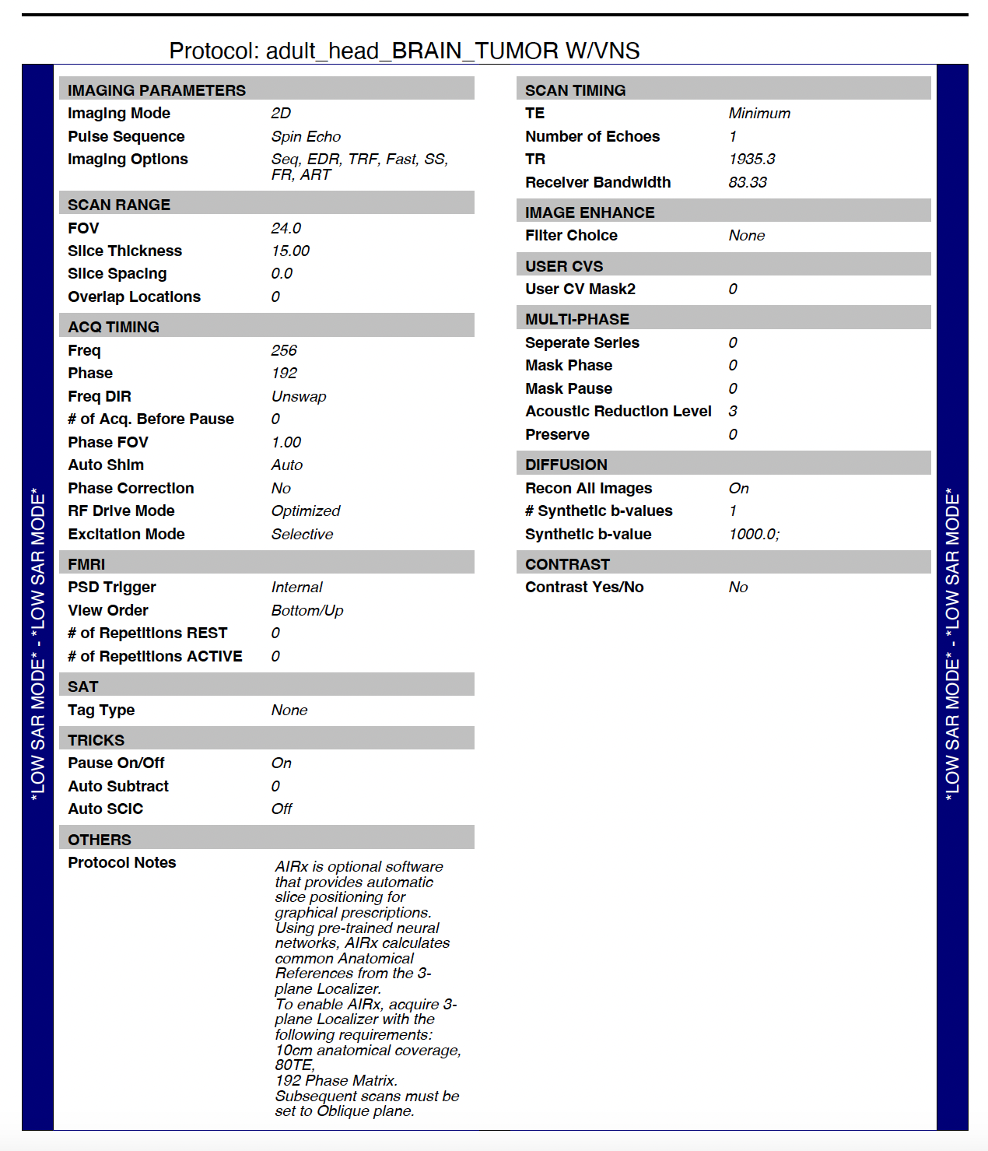

Instructions to authors
on how to get imaging protocols from scanners

Steps to get imaging protocols from Siemens scanner (provided example)

- Reach CT/MRI manager and tech supervisor
- Ask for the protocols to be exported from the scanner as PDFs

- How to export the protocols from the scanner:
- Plug in thumb drive in the scanner computer
- Go to “Lock/Unlock” button on protocol screen and hit “unlock”
- Put in admin username/password
- Click “Dock Cockpit” on main screen which will put you to protocol section
- Click on protocols you want
- Right mouse click, “Export”
- Choose location you want to export
- Wait and system will let you know when it is completed.

